FINALTERM EXAMINATION
MTH603- Numerical Analysis (Session - 2)

Question No: 1 ( Marks: 1 ) - Please choose one
Symbol used for forward differences is

► 

►
►

► 

Question No: 2 ( Marks: 1 ) - Please choose one
The relationship between central difference operator and the shift operator is given by

► 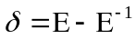
► 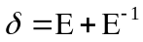
► 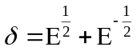
► 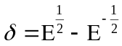

Question No: 3 ( Marks: 1 ) - Please choose one
Muller’s method requires --------starting points

► 1
► 2
► 3
► 4

Question No: 4 ( Marks: 1 ) - Please choose one
If S is an identity matrix, then

► 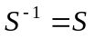
► 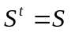
► 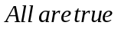
► 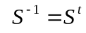

Question No: 5 ( Marks: 1 ) - Please choose one
If we retain r+1 terms in Newton’s forward difference formula, we obtain a polynomial of degree ---- agreeing with 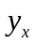 at 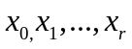

► r+2
► r+1
► r
► r-1

Question No: 6 ( Marks: 1 ) - Please choose one
P in Newton’s forward difference formula is defined as

► 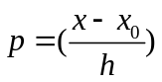

► 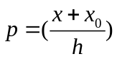
► 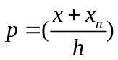
► 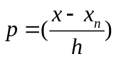

Question No: 7 ( Marks: 1 ) - Please choose one
Octal number system has the base ---------------

► 2
► 8
► 10
► 16

Question No: 8 ( Marks: 1 ) - Please choose one
Newton’s divided difference interpolation formula is used when the values of the independent variable are

► Equally spaced

► Not equally spaced

► Constant
► None of the above

Question No: 9 ( Marks: 1 ) - Please choose one
Given the following data

 | 0 | 1 | 2 | 4
 | 1 | 1 | 2 | 5

Value of 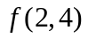is

► 1.5

► 3
► 2

► 1

Question No: 10 ( Marks: 1 ) - Please choose one
If 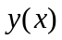is approximated by a polynomial 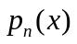 of degree n then the error is given by

► 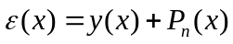
► 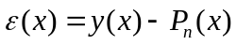
► 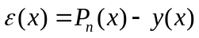
► 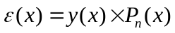

Question No: 11 ( Marks: 1 ) - Please choose one
Let denotes the closed interval spanned by 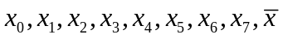. Then vanishes ------times in the interval .

► n-1
► n+2
► n
► n+1

Question No: 12 ( Marks: 1 ) - Please choose one
Differential operator in terms of forward difference operator is given by

► 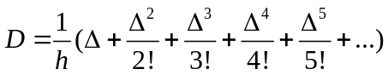
► 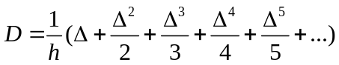
► 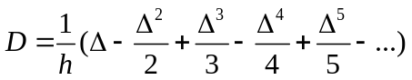
► 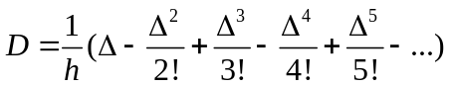

Question No: 13 ( Marks: 1 ) - Please choose one
Finding the first derivative of at =0.4 from the following table:

 | 0.1 | 0.2 | 0.3 | 0.4
 | 1.10517 | 1.22140 | 1.34986 | 1.49182

Differential operator in terms of ----------------will be used.

► Forward difference operator
► Backward difference operator
► Central difference operator
► None of the given choices

Question No: 14 ( Marks: 1 ) - Please choose one
For the given table of values
 | 0.1 | 0.2 | 0.3 | 0.4 | 0.5 | 0.6
 | 0.425 | 0.475 | 0.400 | 0.452 | 0.525 | 0.575

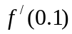, using two-point equation will be calculated as.............

► -0.5
► 0.5
► 0.75
► -0.75

Question No: 15 ( Marks: 1 ) - Please choose one
In Simpson’s 1/3 rule, 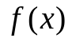is of the form

► 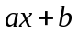
► 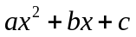
► 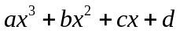
► 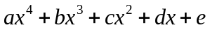

Question No: 16 ( Marks: 1 ) - Please choose one
While integrating 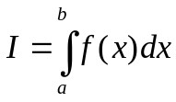, , width of the interval, is found by the formula-----.

► 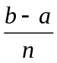
► 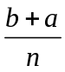
► 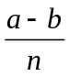
► None of the given choices

Question No: 17 ( Marks: 1 ) - Please choose one
To apply Simpson’s 1/3 rule, valid number of intervals are.....

► 7
► 8
► 5
► 3

Question No: 18 ( Marks: 1 ) - Please choose one
For the given table of values
 | 02 | 0.3 | 0.4 | 0.5 | 0.6 | 0.7
 | 0.425 | 0.475 | 0.400 | 0.452 | 0.525 | 0.575

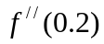, using three-point equation will be calculated as ……

► 17.5
► 12.5
► 7.5
► -12.5

Question No: 19 ( Marks: 1 ) - Please choose one
To apply Simpson’s 1/3 rule, the number of intervals in the following must be

► 2
► 3
► 5
► 7

Question No: 20 ( Marks: 1 ) - Please choose one
To apply Simpson’s 3/8 rule, the number of intervals in the following must be

► 10
► 11
► 12
► 13

Question No: 21 ( Marks: 1 ) - Please choose one
If the root of the given equation lies between a and b, then the first approximation to the root of the equation by bisection method is ……

► 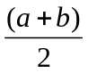
► 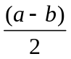
► 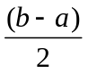
► None of the given choices

Question No: 22 ( Marks: 1 ) - Please choose one
............lies in the category of iterative method.

► Bisection Method
► Regula Falsi Method
► Secant Method
► None of the given choices

Question No: 23 ( Marks: 1 ) - Please choose one
For the equation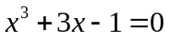, the root of the equation lies in the interval......

► (1, 3)
► (1, 2)
► (0, 1)
► (1, 2)

Question No: 24 ( Marks: 1 ) - Please choose one
Rate of change of any quantity with respect to another can be modeled by

► An ordinary differential equation
► A partial differential equation

► A polynomial equation

► None of the given choices

Question No: 25 ( Marks: 1 ) - Please choose one
If
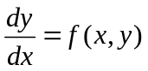
Then the integral of this equation is a curve in

► None of the given choices

► xt-plane
► yt-plane
► xy-plane

Question No: 26 ( Marks: 1 ) - Please choose one
In solving the differential equation
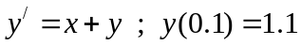
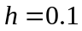, By Euler’s method 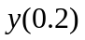 is calculated as

► 1.44
► 1.11
► 1.22
► 1.33

Question No: 27 ( Marks: 1 ) - Please choose one
In second order Runge-Kutta method
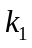 is given by

► 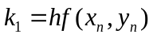
► 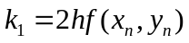
► 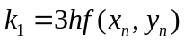
► None of the given choices

Question No: 28 ( Marks: 1 ) - Please choose one
In fourth order Runge-Kutta method, 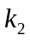 is given by

► 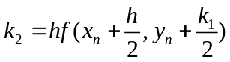
► 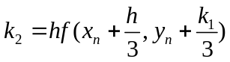
► 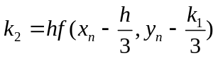
► 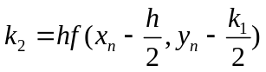

Question No: 29 ( Marks: 1 ) - Please choose one
In fourth order Runge-Kutta method, 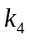 is given by

► 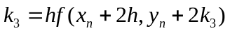
► 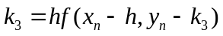
► 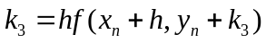
► None of the given choices

Question No: 30 ( Marks: 1 ) - Please choose one
Adam-Moulton P-C method is derived by employing

► Newton’s backward difference interpolation formula
► Newton’s forward difference interpolation formula
► Newton’s divided difference interpolation formula
► None of the given choices

Question No: 31 ( Marks: 2 )
If 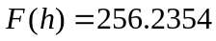 and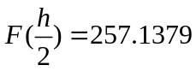, then find 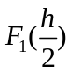using Richardson’s extrapolation limit.

Question No: 32 ( Marks: 2 )
Evaluate the integral
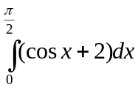
Using Simpson’s 3/8 rule

Take h= 

Question No: 33 ( Marks: 2 )
Write a general formula for Modified Euler’s method of solving the given differential equation.

Question No: 34 ( Marks: 3 )
Evaluate the integral
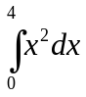
Using Trapezoidal rule
Take h=1

Question No: 35 ( Marks: 3 )
Evaluate the integral
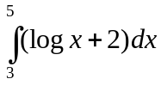
Using Simpson’s 3/8 rule
Take h=1

Question No: 36 ( Marks: 3 )
Write a formula for finding the value of 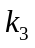in Fourth-order R-K method.

Question No: 37 ( Marks: 5 )
Find Newton’s forward difference table from the following data.

 | 0.0 | 0.1 | 0.2 | 0.3 | 0.4
 | 1 | 0.9048 | 0.8187 | 0.7408 | 0.6703

Question No: 38 ( Marks: 5 )
Evaluate the integral
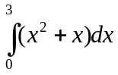
Using Simpson’s 3/8 rule

Take h=1

Question No: 39 ( Marks: 5 )
Use Runge-Kutta Method of order four to find the values of
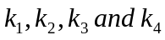 for the initial value problem

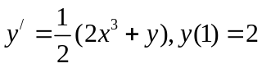 taking

AA
dear fellows
dis iz my paper of math603
more than 5 questn about
simpson 3/8 3 mark 2 mark 2 mark 3 mark etc
trapezal
R-K method 5 marks
2nd derivativ backward diff formula 2 marks
P:C method 5 marks
now about mcqs
Eulaer method fst 2nd derivativ say bht saray mcqs aye thay
calculatn waly
or baki sab simpson trapzel R-K methd

